UNIT 1: Exploring diversity

Activity 1.3: COUNTRIES
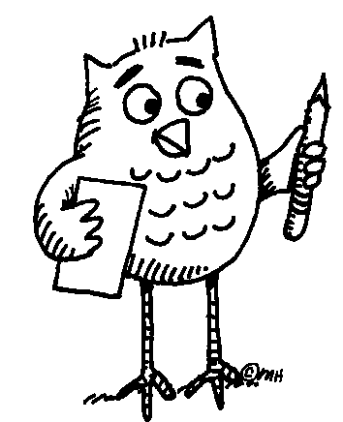 Here is a photocopy of a map of Europe.

Worksheet 1.3.1
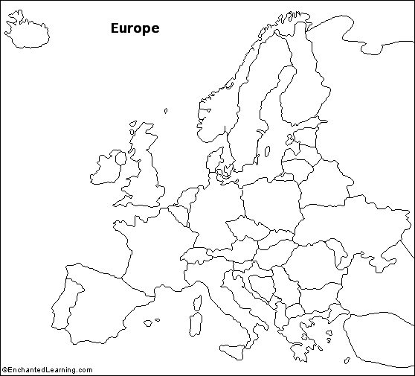
Work in pairs. Find your country and its neighbors. Write their names in English on your map. Try to find the place where you live and make a cross. Write its name here:
………………………………………………………………………………………………….
... Follow up tasks for the whole class:
- Name the countries and show them on a big map of Europe.
- Can you say the names of the neighboring countries in the language of that neighbor?
- Can you teach your classmates how to say the names? They will repeat after you.

